CSS Code Review
10/06/26  Web Programming | Adam Carling  Dr. Barker

Overview

Most of the CSS code was added in the last assignment, however, for this portion, I added in the media queries. The layout for the pages is currently very similar to Wikipedia, because that website contains the hyperlink text inspiration for this project. That might change in the future as I am getting some advice from a friend in graphic design about the layout.
 | Media queries
 | 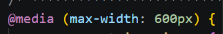  To make the website responsive, I have added media queries. I have three different screen sizes. Under 600px is for phones,  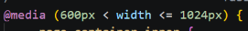  between 600px and 1024px is for tablets. Above 1024px is for computer screens. | The website is not very interactive at the moment, but there are plans to add a hamburger menu and a search bar to the header eventually.

 |  | Recipe-instructions are just that. The instructions for the recipe.
 | Sub-header-content div  I use a div called sub-header-content and create rows and columns with it.  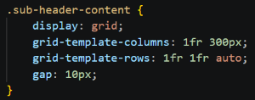  Assigning divs to rows and columns  Each section of the page then gets its own division class and is assigned to a row.  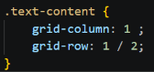  Text-content contains ingredients and any necessary recipe info. | 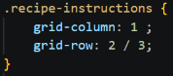  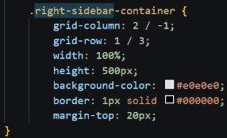  The right-side bar contains an image of the food or item being discussed. It occupies multiple rows but only the far-right column. The idea is that the container should run parallel to the text content and contain some quick reference info like serving size and cooking time.  The result is the image below.
 | 

